ASSIGNMENT-3

1.Create a bucket in IBM storage

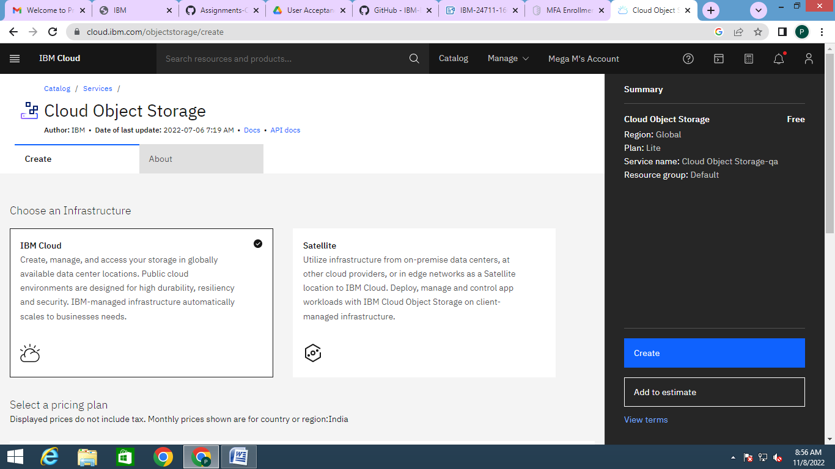

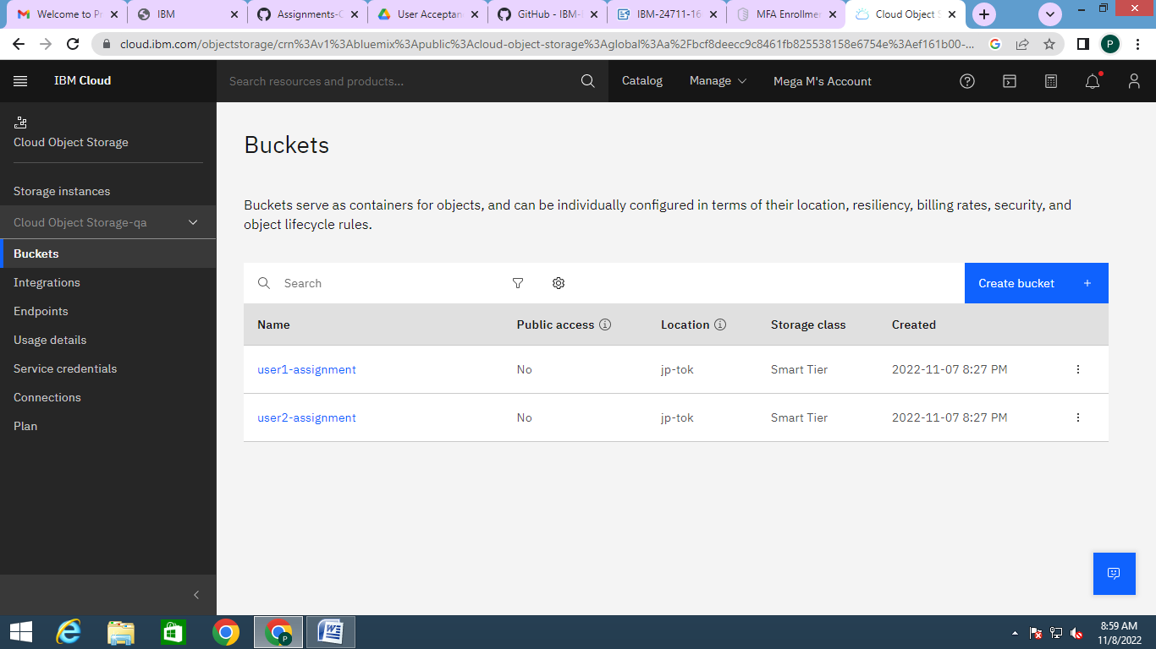

2) Upload a 5 image to IBM object storage and make it public. Write HTML code to display all the 5 images:

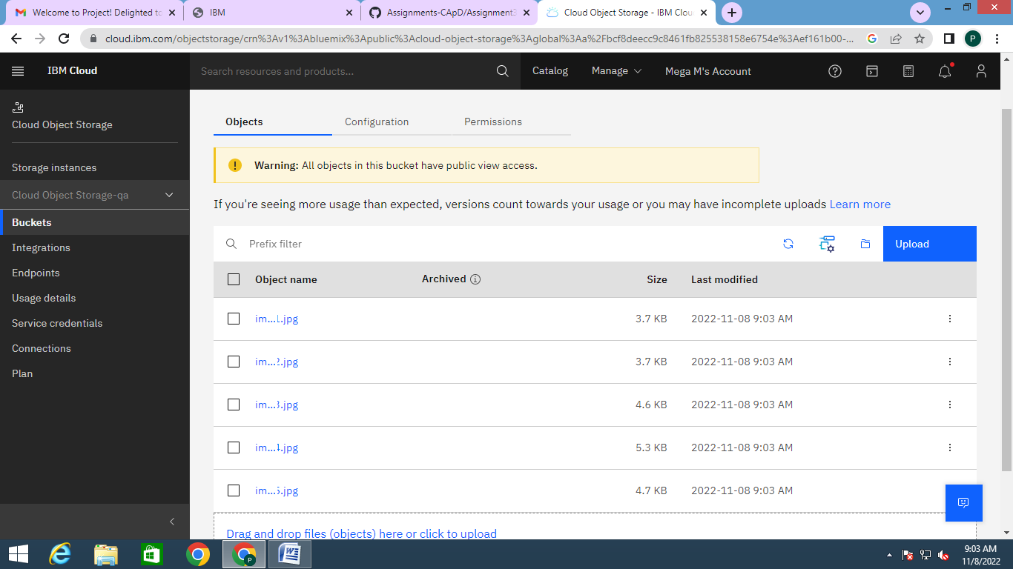

Image URL

<https://user1-assignment.s3.jp-tok.cloud-object-storage.appdomain.cloud/image1.jpg>

<https://user1-assignment.s3.jp-tok.cloud-object-storage.appdomain.cloud/image2.jpg>

<https://user1-assignment.s3.jp-tok.cloud-object-storage.appdomain.cloud/image3.jpg>

<https://user1-assignment.s3.jp-tok.cloud-object-storage.appdomain.cloud/image4.jpg>

<https://user1-assignment.s3.jp-tok.cloud-object-storage.appdomain.cloud/image5.jpg>

HTML CODE:

<html>

<head><title>Images</title></head>

<body>

<img src="https://user1-assignment.s3.jp-tok.cloud-object-storage.appdomain.cloud/image1.jpg" style="width:200px;height:200px;">

<img src="https://user1-assignment.s3.jp-tok.cloud-object-storage.appdomain.cloud/image2.jpg" style="width:200px;height:200px;">

<img src="https://user1-assignment.s3.jp-tok.cloud-object-storage.appdomain.cloud/image3.jpg" style="width:200px;height:200px;">

<img src="https://user1-assignment.s3.jp-tok.cloud-object-storage.appdomain.cloud/image4.jpg" style="width:200px;height:200px;">

<img src="https://user1-assignment.s3.jp-tok.cloud-object-storage.appdomain.cloud/image5.jpg" style="width:200px;height:200px;">

</body>

</html>

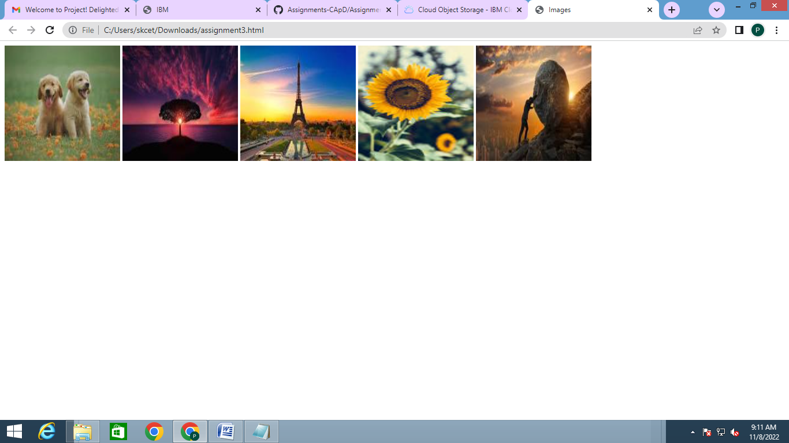

3. Upload a CSS page to the object storage and use the same page in your HTML code:

<style>

body{

background-color:grey;

}

img{

padding:20px;

}

</style>

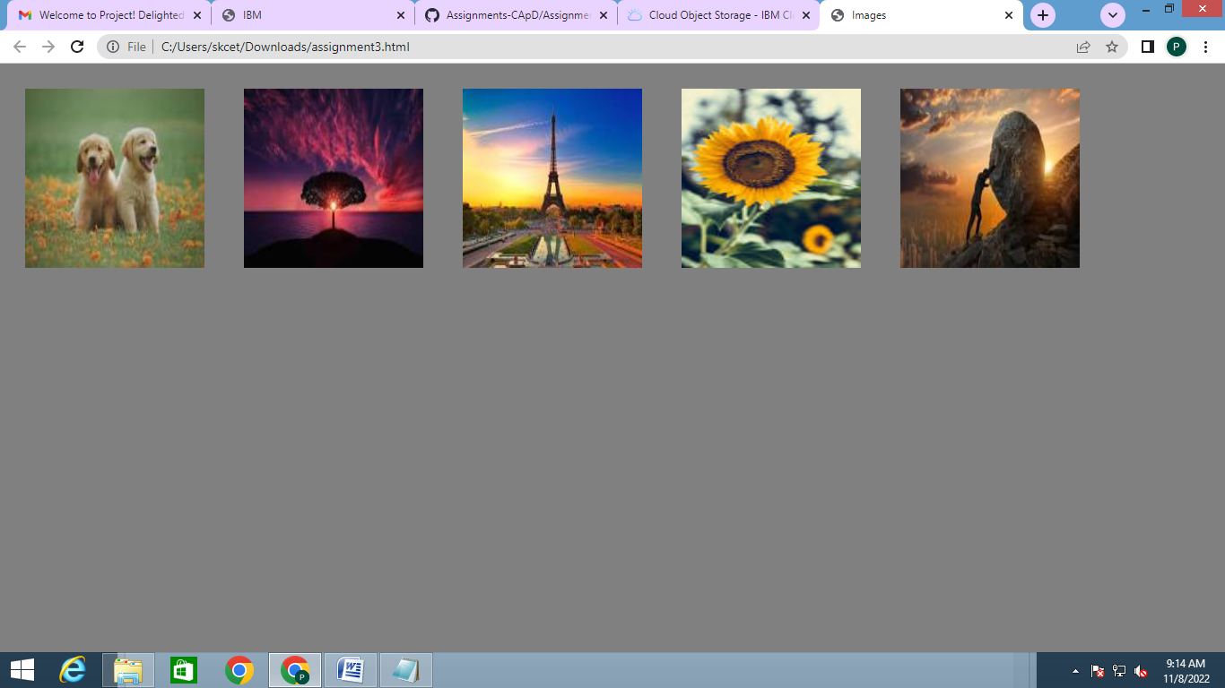

4. Design a chatbot using IBM Watson assistant for hospital. Ex: User comes with query to know the branches for the hospital in your city. Submit the web URL of chatbot as a assignment:

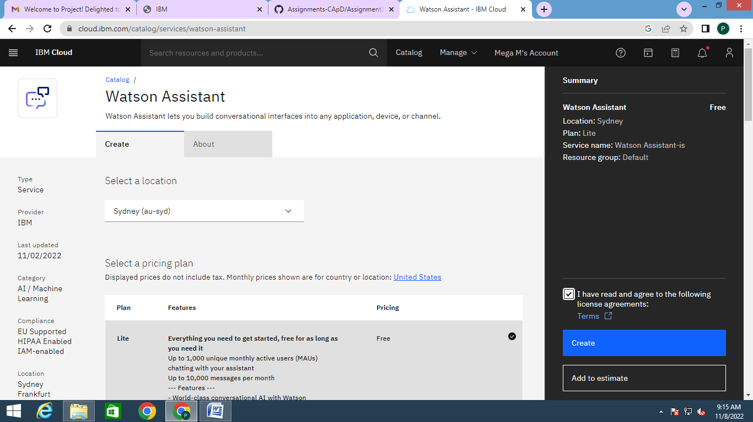

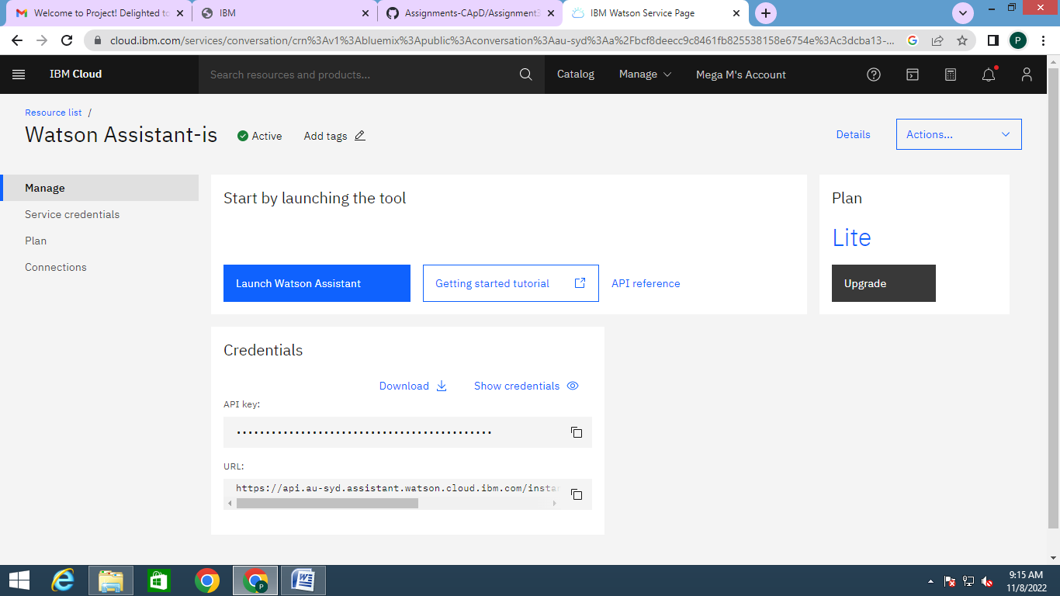

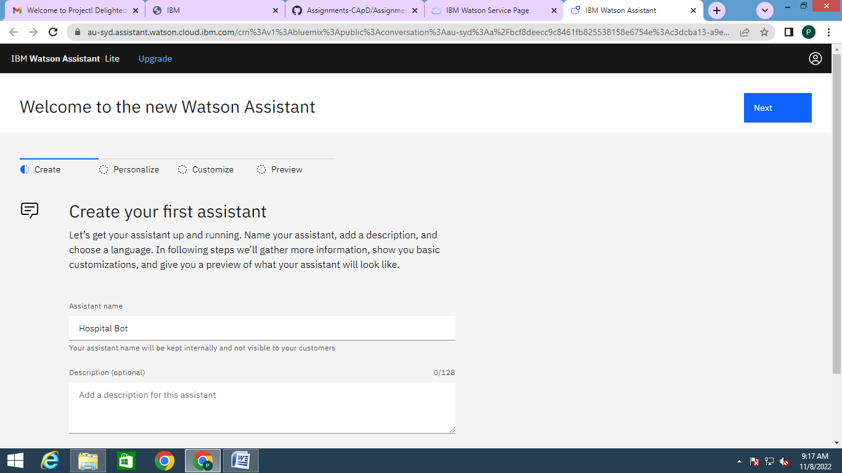

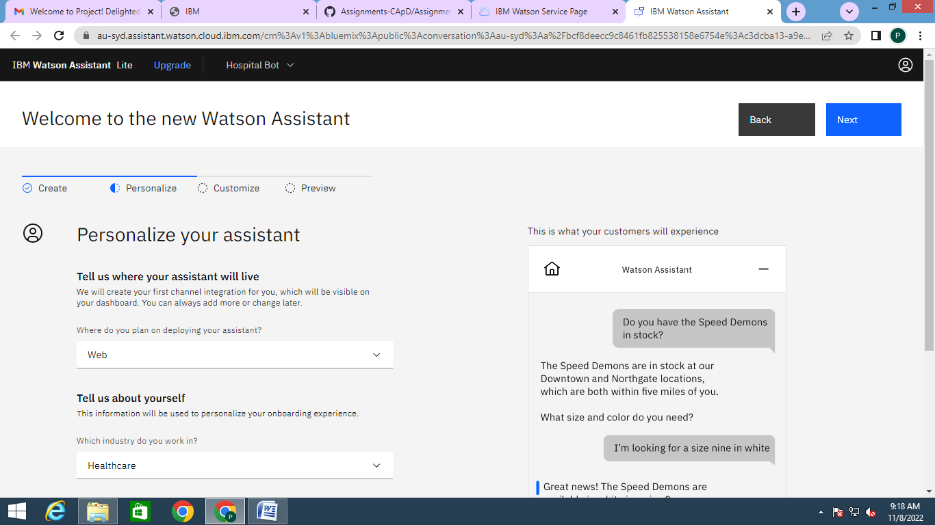

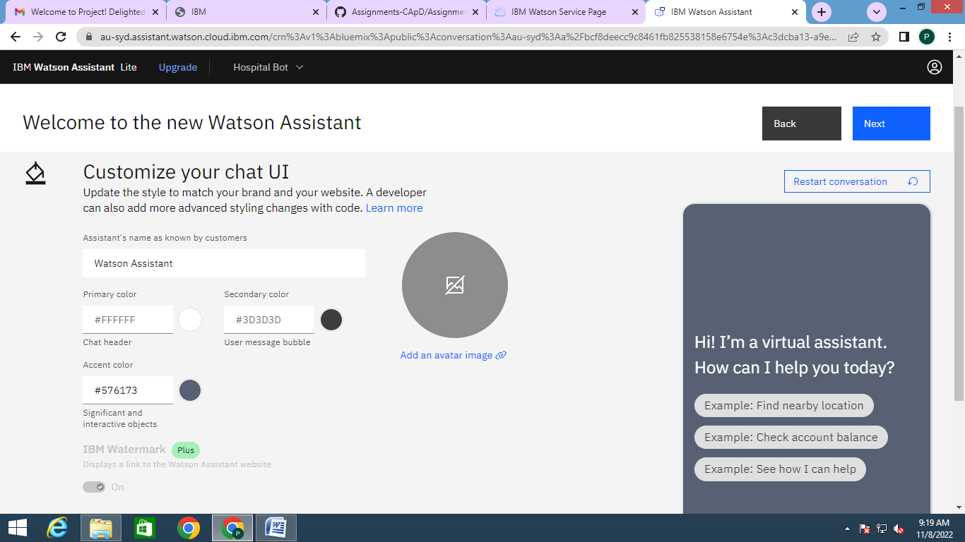

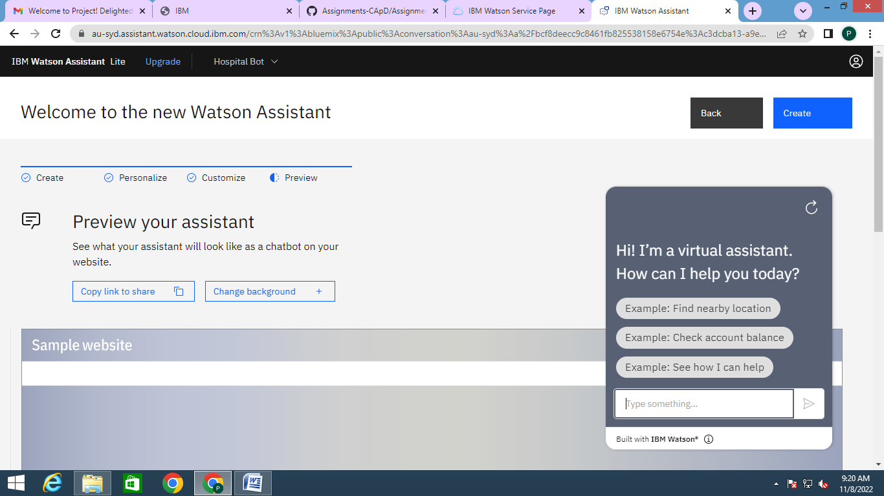

Link: <https://web-chat.global.assistant.watson.appdomain.cloud/preview.html?backgroundImageURL=https%3A%2F%2Fau-syd.assistant.watson.cloud.ibm.com%2Fpublic%2Fimages%2Fupx-c3dcba13-a9ed-44a3-b9dc-f123d3df3752%3A%3Aa7a3c99a-685c-48d6-8150-c06471598ffb&integrationID=f4845306-64c9-4347-b3c6-2a29d55d3976&region=au-syd&serviceInstanceID=c3dcba13-a9ed-44a3-b9dc-f123d3df3752>

5. Create Watson assistant with 10 steps and use 3 conditions in it. Load that script in HTML page:

